RC CAR

TINKER CAD SIMULATION & ARDUINO PROGRAMMING

PROJECT OVERVIEW:

This project simulates a remote-controlled (RC) car. It uses an L293D motor driver to control a DC motor and two push buttons for directional input. The Arduino reads the button states and drives the motor forward or backward accordingly, demonstrating basic motor control and digital input handling in a virtual environment.

1.OBJECTIVES:

Understand motor control using the L293D motor driver IC with Arduino.

Learn digital input handling by using push buttons to control motor direction.

Simulate and test circuits virtually using Tinkercad before physical implementation.

Integrate hardware components like DC motors, buttons, and microcontrollers in a cohesive system.

Develop basic Arduino programming skills for reading inputs and controlling outputs.

Build a functional RC car prototype that responds to user input for directional movement.

2.INTRODUCTION:

This project focuses on building a basic remote-controlled car system that demonstrates how to control the direction of a motor using electronic components. It involves using a microcontroller to read input from push buttons and control a motor driver, which in turn operates a DC motor. The setup allows the motor to move forward or backward based on user input, providing a practical understanding of motor control, digital input processing, and circuit integration. This project serves as a foundational exercise in electronics and embedded systems.

3.BLOCK DIAGRAM:
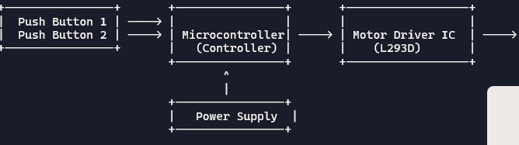

4.COMPONENTS:
Name | Quantity | Component
U1 | 1 | Arduino Uno R3
M1 | 1 | DC Motor
S1, S2 | 2 | Pushbutton
U2 | 1 | H-bridge Motor Driver

5.WIRING AND PIN DIAGRAM:

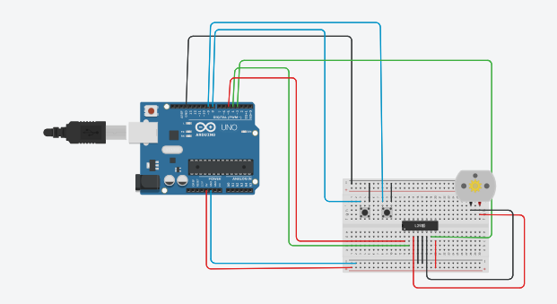

Component | Pin / Terminal | Connected To
Arduino UNO | 5V | Breadboard + rail
Arduino UNO | GND | Breadboard – rail
Arduino UNO | D9 | L293D Pin 1 (EN1)
Arduino UNO | D8 | L293D Pin 2 (IN1)
Arduino UNO | D7 | L293D Pin 7 (IN2)
Arduino UNO | D2 | Push Button 1
Arduino UNO | D3 | Push Button 2
Push Button 1 | Other pin | GND
Push Button 2 | Other pin | GND
L293D | Pin 16 (Vcc1) | Arduino 5V
L293D | Pin 8 (Vcc2) | 5V / Motor supply
L293D | Pin 4, 5 | GND
L293D | Pin 3 (OUT1) | DC Motor Terminal 1
L293D | Pin 6 (OUT2) | DC Motor Terminal 2
DC Motor | Terminal 1 | L293D Pin 3
DC Motor | Terminal 2 | L293D Pin 6

BUILDING CIRCUITS IN TINKERCAD:

Open Tinkercad → Circuits → Create New Circuit.

Drag Arduino UNO, breadboard, L293D motor driver, DC motor, and two push buttons into the workspace.

Connect Arduino 5V to the breadboard positive (+) rail.

Connect Arduino GND to the breadboard negative (–) rail.

Place the L293D IC across the center gap of the breadboard.

Connect L293D pin 16 to +5V and pins 4 and 5 to GND.

Connect L293D pin 8 to +5V (motor supply).

Connect the DC motor terminals to L293D pins 3 and 6.

Connect Arduino D9 to L293D pin 1 (Enable).

Connect Arduino D8 to L293D pin 2 (IN1).

Connect Arduino D7 to L293D pin 7 (IN2).

Place both push buttons across the breadboard gap.

Connect Button 1: one side to Arduino D2, other side to GND.

Connect Button 2: one side to Arduino D3, other side to GND.

Click Start Simulation, upload the Arduino code, and test the motor using the buttons.

7.ARDUINO CODE:

int MPin=9; //motor pin

int Analog=A0; //Analog Input

int Ainp=0; //Read analog input,initialized to zero

void setup()

{

Serial.begin(9600);

pinMode(MPin,OUTPUT);

pinMode(Analog,INPUT);

}

void loop()

{

Ainp=analogRead(A0);

int Speed=map(Ainp,0,1024,0,255);

delay(100);

Serial.println(Speed);

analogWrite(MPin,Speed);

}

8.CODE EXPLANATION:

The program is used to control the speed of a motor using an analog input.

Pin 9 is used as the motor control pin (PWM).

Pin A0 is used to read analog input from a potentiometer or sensor.

The setup() function initializes serial communication and sets pin modes.

The analogRead() function reads the analog value (0–1023).

The map() function converts the analog value to a PWM range (0–255).

The PWM value represents the motor speed.

The speed value is displayed on the Serial Monitor.

The analogWrite() function controls the motor speed.

The process repeats continuously in the loop() function.

9.TESTING AND DEBUGGING IN TINKERCAD:

Tinkercad is used to simulate Arduino circuits without hardware.

The Start Simulation option runs the program.

Code errors are shown before simulation.

The Serial Monitor helps check output values.

Circuit wiring can be visually verified.

Components can be adjusted during simulation.

Errors are fixed by modifying code or connections and re-running the simulation.

10.WHAT IF TESTING AND BEHAVIOUR ANALYSIS:

Testing is the process of checking whether the circuit and code work as expected.

It ensures correct functioning of components and program logic.

Inputs are varied to verify correct outputs.

Behaviour analysis studies how the system responds to different input conditions.

It observes changes in output when input values increase or decrease.

It helps understand system performance, stability, and correctness.

Unexpected behaviour indicates errors in code or circuit design.

Together, testing and behaviour analysis confirm reliable system operation.

11.OBSERVATIONS:

During testing, the program executed without errors and the analog input value changed smoothly when the input was adjusted. The corresponding PWM output varied correctly, causing the motor speed to increase or decrease as expected. The speed values were displayed properly on the Serial Monitor, and the motor responded in real time to input changes, showing stable and correct behavior throughout the operation.

LINK:

https://www.tinkercad.com/things/9jnyuMFVDSw-cool-elzing-maimu

